**Name : Akash Arjun Sawant**

**Email ID :** [**sawantakash106@gmail.com**](mailto:sawantakash106@gmail.com)

**Day 4 Assignment (Cyber Security Essentials)**

**Solution :**

**Q1) Find out the mail servers of the following domain:**

* **Ibm.com**
* **Wipro.com**

Open -> PenTester VMware workstation

Open -> Command Prompt

Type

> ipconfig

> nslookup

> [www.Ibm.com](http://www.Ibm.com)

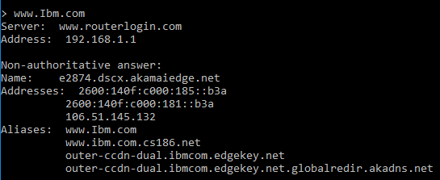

**>** [www.Wipro.com](http://www.Wipro.com)

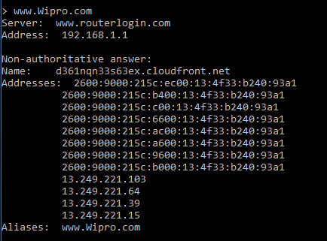

**Q2) Find the locations, where these email servers are hosted.**

Type

> set type=mx

> Ibm.com

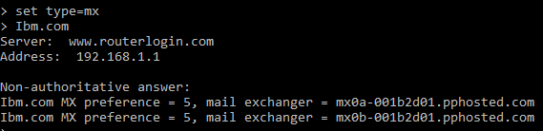

Location

Address 1

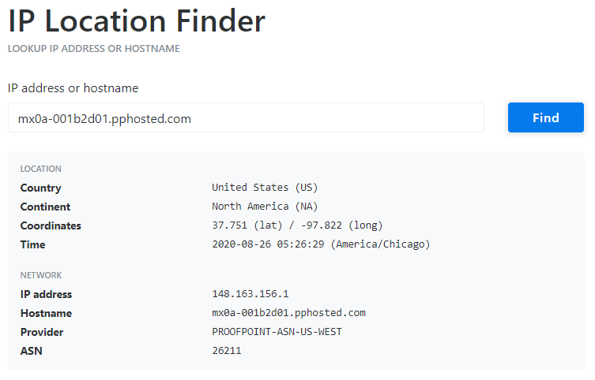

Address 2

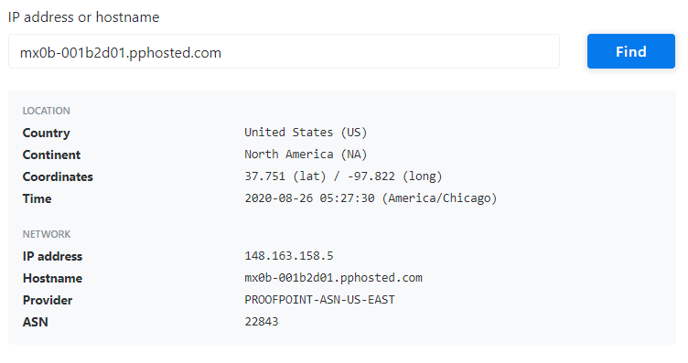

> Wipro.com

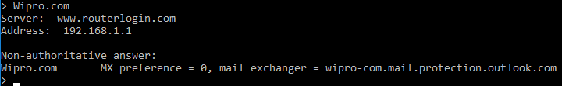

Location

Address

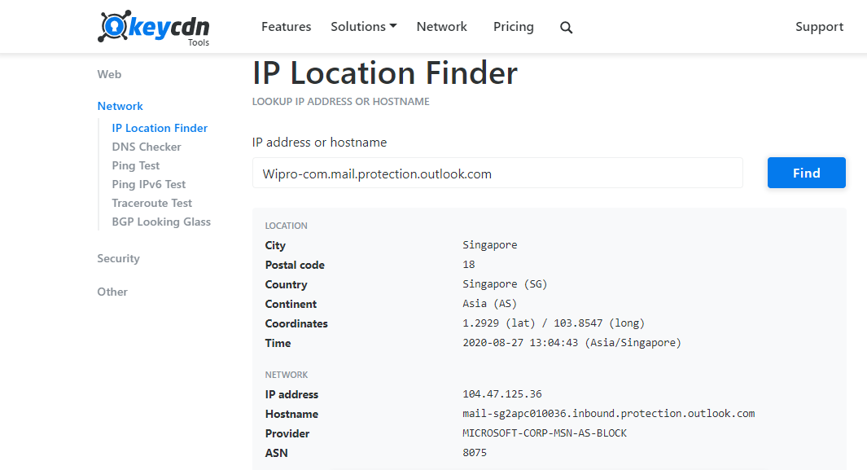

**Q3) Scan and find out port numbers open 203.163.246.23**

**Use -> Kali**

Type

> sudo su –

> Enter password

> nmap –Pn –sS 203.163.246.23

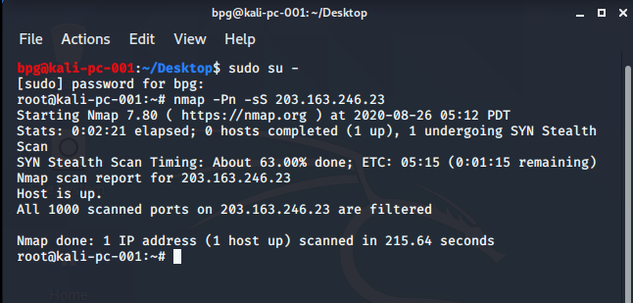

**Some extra alternative commands**

> -sS -v -v -Pn 203.163.246.23

> nmap -6 203.163.246.23

> nmap -p 22,25,135 -Pn -v –b 203.163.246.23 scanme.nmap.org

> nmap -vv -n -sS -Pn --ip-options "L 203.163.246.23 " --reason 203.163.246.23

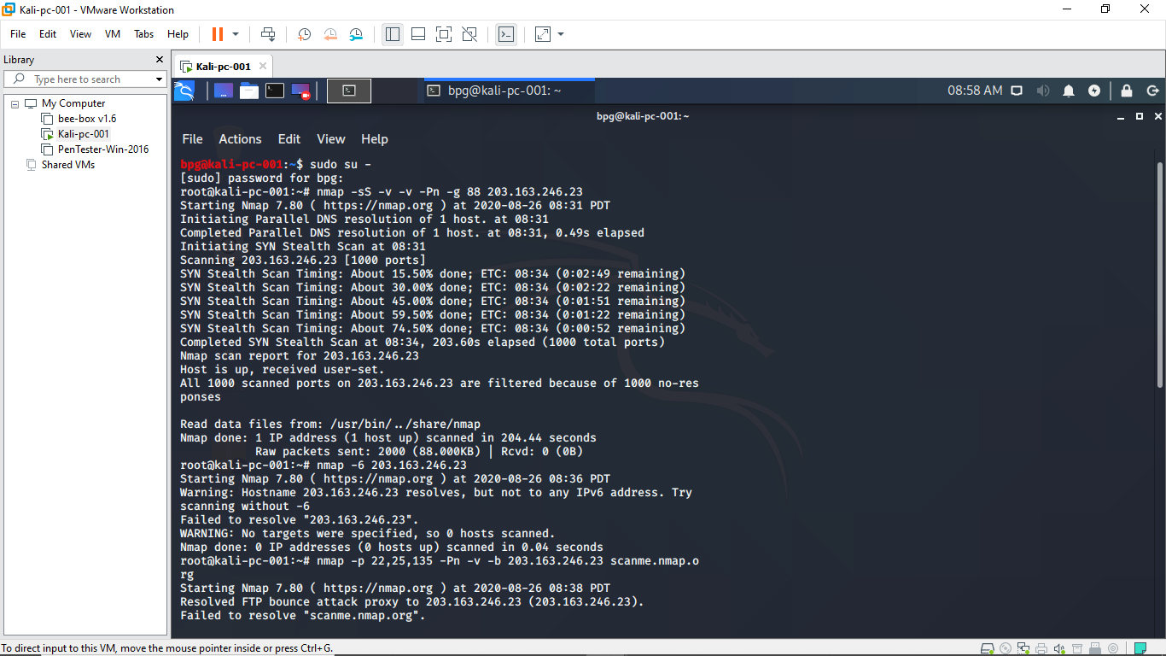

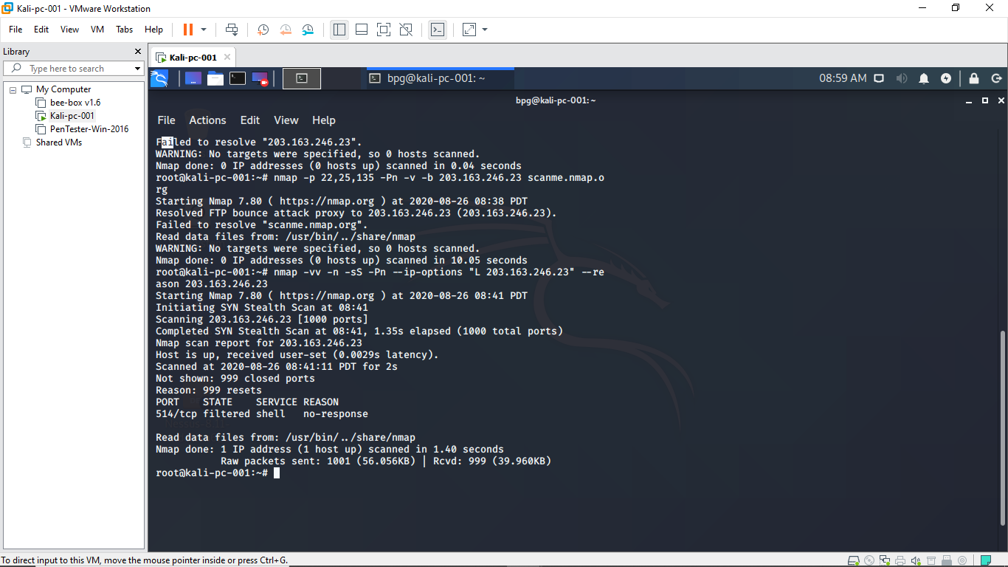

**Q4) Install nessus in a VM and scan your laptop/desktop for CVE**

